SRWE Practice Exam, Part 1
Switching, EtherChannel, trunking and inter-VLAN routing in Packet Tracer
This document goes through the lab device by device, in the order the devices were configured. Each section has the Packet Tracer screenshot, an explanation of what the commands do, and the errors that came up along the way. Near the end there is a list of things that still need checking, followed by a clean copy of each device's configuration.

1. What the lab builds
There are two LANs behind one edge router. The Sciences LAN has a Layer 3 switch (L3-SW1) and two access switches (Sw-A and Sw-B) carrying VLANs 10, 20 and 30. The Arts LAN has one switch (Sw-C) carrying VLANs 40, 50 and 60, plus VLAN 99 for management. The Edge-Router connects both LANs to the ISP and the outside server at 203.0.113.100.
Inter-VLAN routing is done two different ways on purpose: SVIs on the Layer 3 switch for the Sciences LAN, and router-on-a-stick (subinterfaces) on the Edge-Router for the Arts LAN. The bottom half of the instruction sheet in Figure 1 (Part 5) is what this document covers.
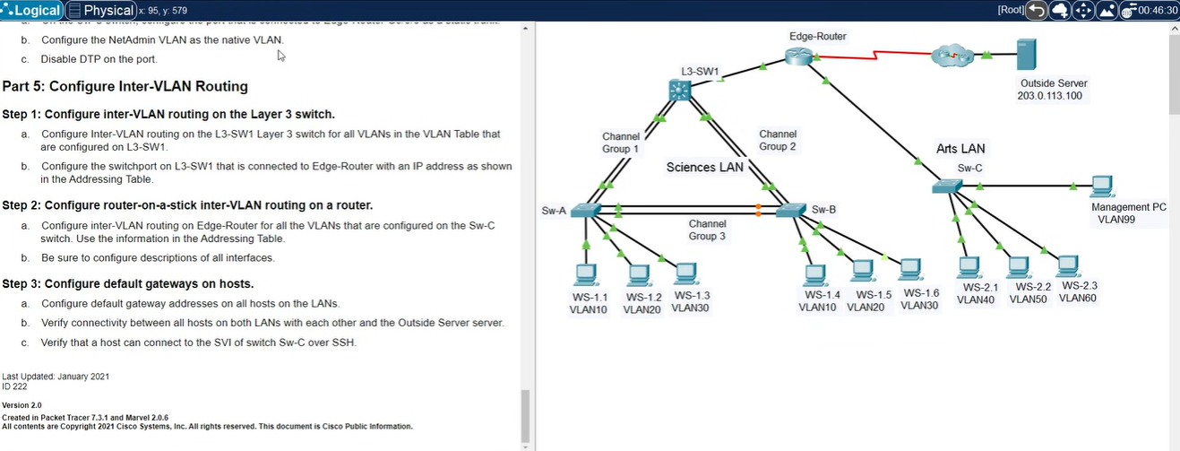
Figure 1. Topology and the Part 5 instructions (inter-VLAN routing).

Device names
The topology labels and the hostnames typed in the CLI are not the same. The mapping below comes from the topology and from which VLANs each device carries.
Topology label | CLI hostname | Role
Sw-A | S-1 | Access switch, Sciences LAN (hosts WS-1.1 to 1.3)
Sw-B | S-2 | Access switch, Sciences LAN (hosts WS-1.4 to 1.6)
Sw-C | S-3 | Access switch, Arts LAN, plus the management PC
L3-SW1 | MSW-1 (tab name MULTI-1) | Multilayer switch, routes VLANs 10, 20, 30 with SVIs
Edge-Router | R1 (tab name R-1) | Router-on-a-stick for the Arts LAN, static routes, link to ISP

Links
Link | Ports | Notes
L3-SW1 to Sw-A | MSW-1 g1/0/1-2, S-1 g0/1-2 | Channel Group 1, Port-channel 1 on both ends, trunk
L3-SW1 to Sw-B | MSW-1 g1/0/3-4, S-2 g0/1-2 | Channel Group 2, Port-channel 2 on both ends, trunk
Sw-A to Sw-B | fa0/5-6 on both | Channel Group 3, Port-channel 3 on both ends, trunk
L3-SW1 to Edge-Router | MSW-1 g1/1/1, R1 g0/0/0 | Routed link, 10.0.0.0/24 (switch .2, router .1)
Edge-Router to Sw-C | R1 g0/0/1, S-3 g0/1 | Trunk, native VLAN 99, subinterfaces on the router
Edge-Router to ISP | R1 s0/1/0 | 209.165.201.2/30

VLANs and addressing used in the screenshots
VLAN | Name | LAN | Subnet | Default gateway
10 | FL1 | Sciences | 172.31.10.0/24 | 172.31.10.1 (SVI on MSW-1)
20 | FL2 | Sciences | 172.31.20.0/24 | 172.31.20.1 (SVI on MSW-1)
30 | FL3 | Sciences | 172.31.30.0/24 | 172.31.30.1 (SVI on MSW-1)
40 | BDG4 | Arts | 172.31.40.0/24 | 172.31.40.1 (R1 g0/0/1.40)
50 | BDG5 | Arts | 172.31.50.0/24 | 172.31.50.1 (R1 g0/0/1.50)
60 | BDG6 | Arts | 172.31.60.0/24 | 172.31.60.1 (R1 g0/0/1.60)
99 | Management | Arts | 172.31.99.16/28 | 172.31.99.17 (R1 g0/0/1.99)

Access port assignments: on S-1 and S-2, fa0/7-10 are VLAN 10, fa0/11-15 are VLAN 20 and fa0/16-24 are VLAN 30. On S-3, fa0/1-5 are VLAN 40, fa0/6-10 are VLAN 50, fa0/11-15 are VLAN 60 and fa0/24 is VLAN 99.

2. S-1 (Sw-A): VLANs, access ports and EtherChannels
S-1 is configured first. VLANs 10, 20 and 30 are created and named FL1, FL2 and FL3. The access ports are split into three ranges, and each range gets switchport mode access before switchport access vlan X. Setting the mode explicitly stops the port from trying to negotiate a trunk with whatever is plugged in.
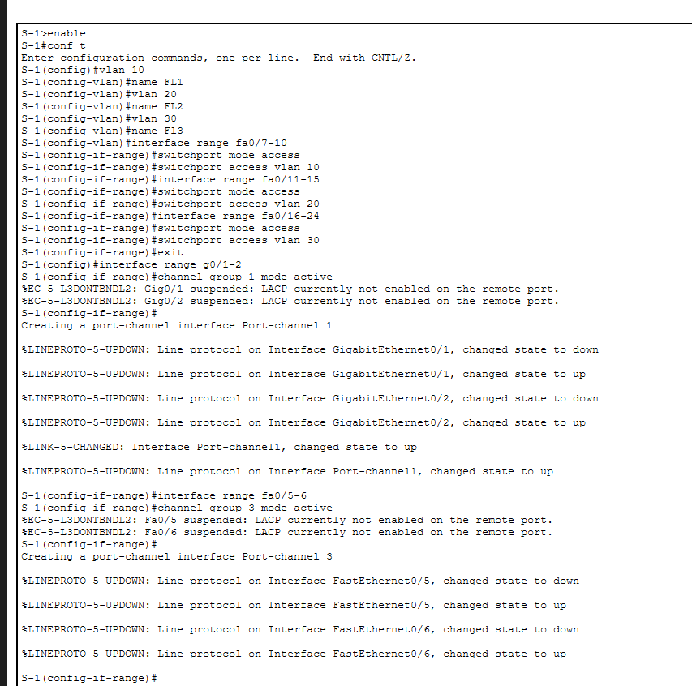
Figure 2. S-1: VLANs, access port ranges and creation of Port-channel 1 and 3.
Two EtherChannels are built with LACP:
- channel-group 1 mode active on g0/1-2 creates Port-channel 1, the uplink to L3-SW1.
- channel-group 3 mode active on fa0/5-6 creates Port-channel 3, the link to S-2.
The %EC-5-L3DONTBNDL2 ... LACP currently not enabled on the remote port lines appear because the switch at the other end has not been configured yet. They are expected at this stage. The up/down messages that follow are the member ports being re-bundled into the port-channel.
Trunking is then set on the port-channel interfaces, not on the physical members. The members inherit the setting from the port-channel.
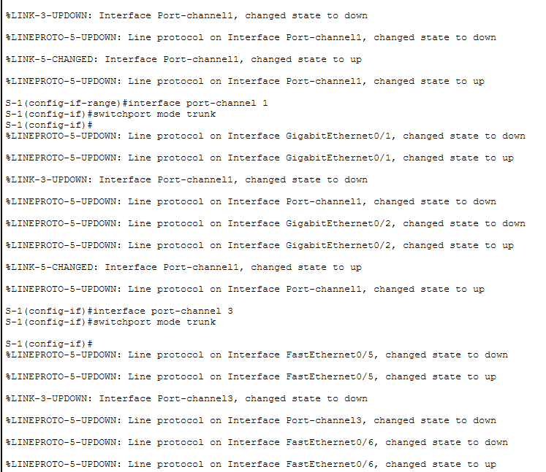
Figure 3. S-1: Port-channel 1 and 3 set to trunk mode.
The repeated link flaps in Figure 3 come from the bundle renegotiating each time the port-channel mode changes. They stop once both ends agree.

3. S-2 (Sw-B): same VLANs, plus two problems
S-2 gets the same VLANs and the same access port ranges as S-1. The difference is the channel group number on the uplink: channel-group 2 on g0/1-2. Channel group numbers only matter locally, so 2 on S-2 and 1 on S-1 both connecting to MSW-1 is fine.
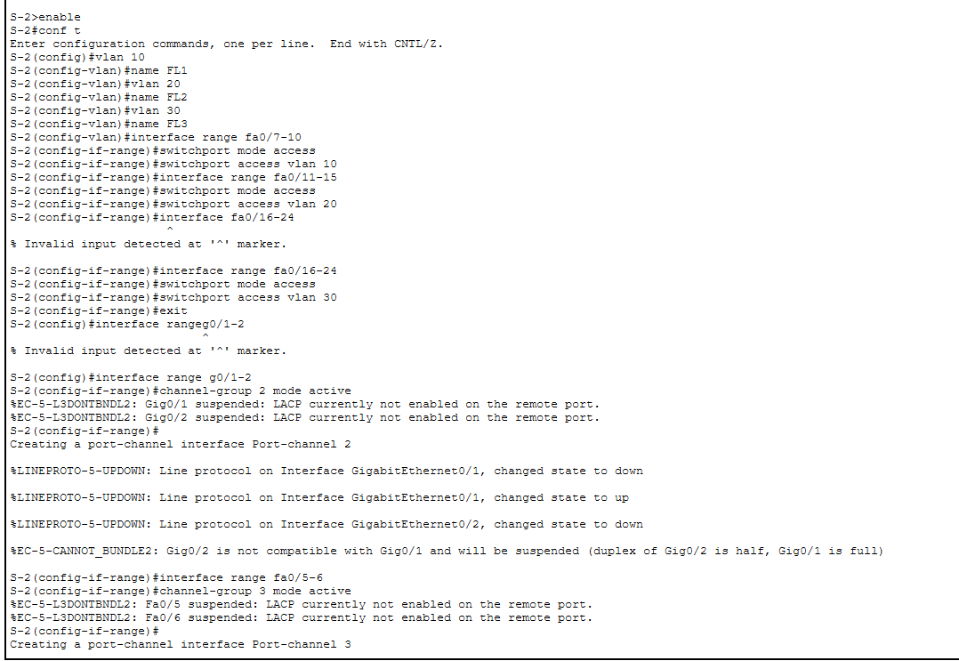
Figure 4. S-2: VLANs, access ports and the first EtherChannel attempts.
Two typing mistakes show up in Figure 4. interface fa0/16-24 was rejected because a range needs the word range, and interface rangeg0/1-2 was missing the space. Both were retyped correctly.
The more important message is this one:
%EC-5-CANNOT_BUNDLE2: Gig0/2 is not compatible with Gig0/1 and will be suspended
(duplex of Gig0/2 is half, Gig0/1 is full)
Every port in an EtherChannel must have the same speed and duplex. Gig0/2 negotiated half duplex while Gig0/1 is full, so IOS suspends one of them. The bundle still works with a single link, but the redundancy is gone. The same thing happens on MSW-1 (Gig1/0/3 is half, Gig1/0/4 is full), so it is probably the two ends of the same cable. The fix is to set both ends of that link explicitly:
interface range g0/1-2
speed 1000
duplex full
Then confirm with show etherchannel summary. Both ports should show P (bundled), not s (suspended).
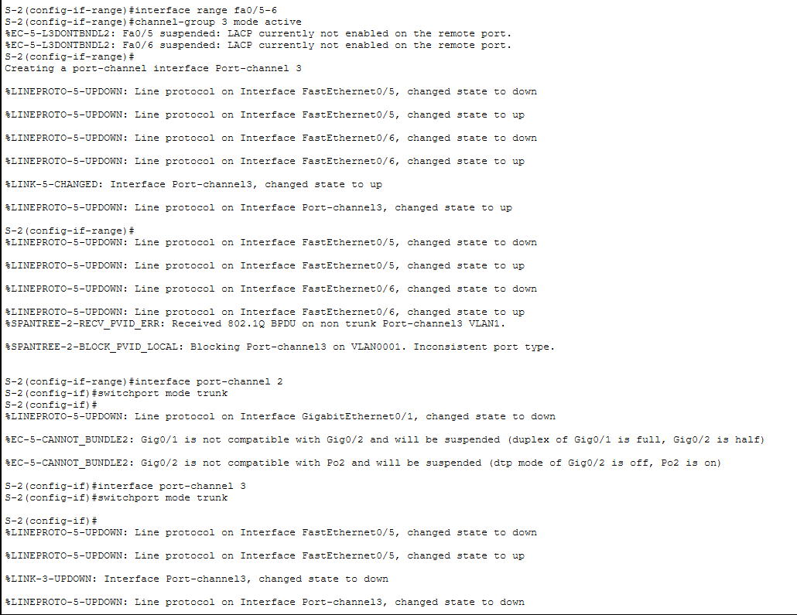
Figure 5. S-2: Port-channel 3 created, then the STP and DTP/duplex errors when trunking is set.
Figure 5 has two more messages worth understanding:
- `%SPANTREE-2-RECV_PVID_ERR` and `BLOCK_PVID_LOCAL` on Port-channel 3. S-1 already had Port-channel 3 as a trunk and was sending tagged BPDUs. S-2's Port-channel 3 was still an access port, so spanning tree blocked it. It cleared after switchport mode trunk was applied on S-2's Port-channel 3. Order matters when configuring both ends.
- `dtp mode of Gig0/2 is off, Po2 is on`. Gig0/2 was already suspended for the duplex reason, so it kept its old settings while Port-channel 2 changed to trunk. It should rejoin once the duplex problem is fixed.

4. S-3 (Sw-C): management, SSH, VLANs and the trunk to the router
S-3 does not take part in any EtherChannel. It has three jobs: give the Arts LAN its VLANs, be reachable for management over SSH on VLAN 99, and trunk to the Edge-Router.

Management address and SSH
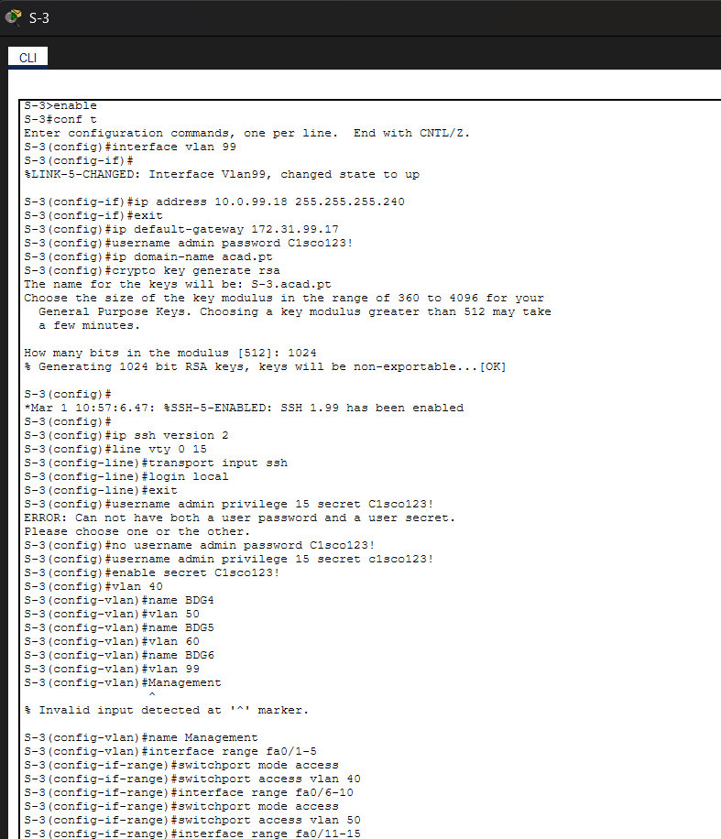
Figure 6. S-3: VLAN 99 interface, SSH setup, user accounts and VLAN creation.
SSH on a Cisco switch needs all of these in place:
- A hostname and a domain name (ip domain-name acad.pt). The RSA key name is built from both, which is why the output says S-3.acad.pt.
- An RSA key pair: crypto key generate rsa with a 1024-bit modulus. Version 2 needs at least 768 bits.
- ip ssh version 2. Without it the switch reports "SSH 1.99", meaning it accepts version 1 and 2.
- A local user, and login local with transport input ssh on line vty 0 15.
username admin password ... followed by username admin privilege 15 secret ... gave the error "Can not have both a user password and a user secret". The old password entry was removed with no username admin password C1sco123!, and the account was recreated with a secret. The secret is stored hashed, so it is the better of the two.
ip default-gateway 172.31.99.17 is the router's VLAN 99 subinterface. A Layer 2 switch needs a default gateway so that management traffic from other subnets (including the SSH test in Part 5 Step 3c) has somewhere to go. See the check list in section 8, because the VLAN 99 address on this switch does not match this gateway.

VLANs, access ports and the trunk
VLANs 40, 50, 60 and 99 are created and named BDG4, BDG5, BDG6 and Management. The first attempt typed Management without name in front of it and was rejected. Access ports follow the table in section 1, with fa0/24 in VLAN 99 for the management PC.
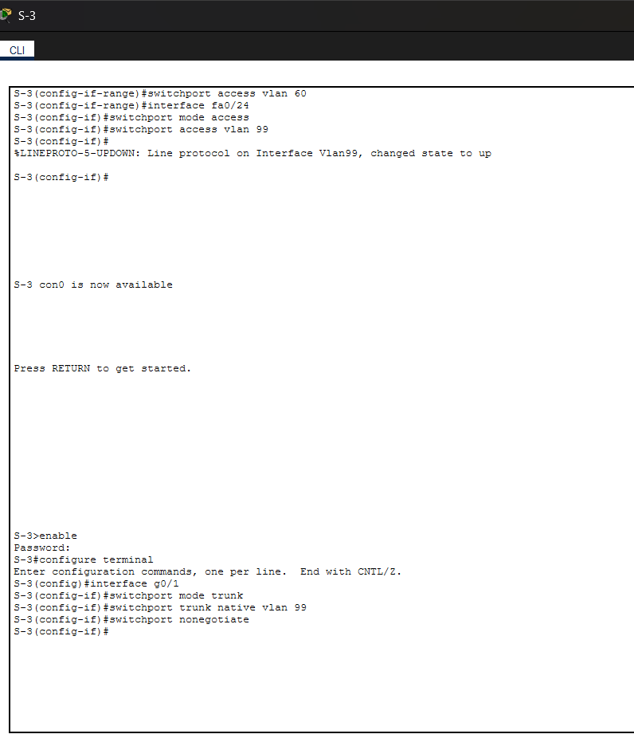
Figure 7. S-3: remaining access ports and the trunk to the Edge-Router on g0/1.
The uplink to the router is set as a static trunk:
interface g0/1
switchport mode trunk
switchport trunk native vlan 99
switchport nonegotiate
- switchport mode trunk forces trunking, no negotiation.
- native vlan 99 moves untagged traffic to the management VLAN. The router must agree, which is why its VLAN 99 subinterface uses encapsulation dot1q 99 native. If the two ends disagree on the native VLAN, untagged frames land in the wrong VLAN and CDP will warn about a mismatch.
- switchport nonegotiate turns DTP off on the port. This matches step 4c of the instructions.

5. Edge-Router (R1): base settings, WAN and router-on-a-stick

Base configuration and routes
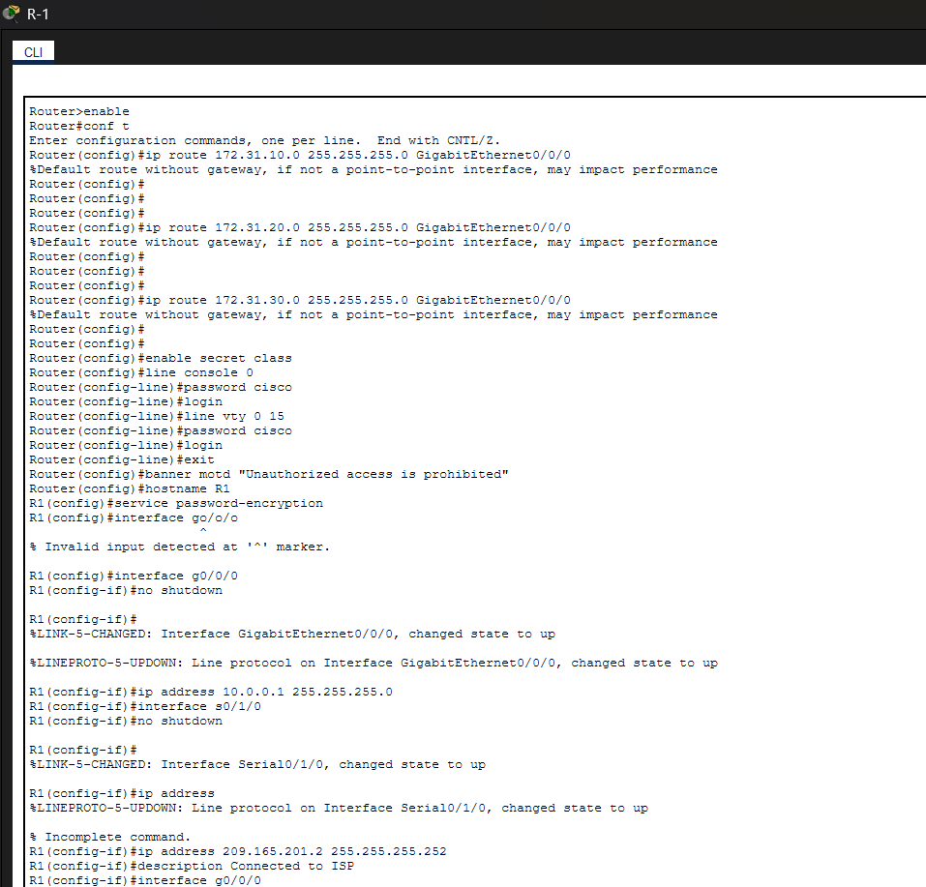
Figure 8. R1: static routes, passwords, banner, hostname, and the first interface configuration.
- Three static routes to 172.31.10.0, .20.0 and .30.0 (all /24) point out g0/0/0, toward L3-SW1. These are the Sciences LAN subnets that the router does not have directly connected.
- The warning "Default route without gateway, if not a point-to-point interface, may impact performance" appears because the routes use an exit interface on an Ethernet link instead of a next-hop address. It works, but on a multi-access link the router has to ARP for every destination. Using the next hop instead, ip route 172.31.10.0 255.255.255.0 10.0.0.2, avoids that.
- enable secret class, console and VTY passwords set to cisco with login, a MOTD banner, and service password-encryption so the line passwords are not shown in plain text in the running config.
- interface go/o/o failed because the name had the letter o instead of the digit 0. The correct form is interface g0/0/0.
- g0/0/0 gets 10.0.0.1/24 and is brought up with no shutdown. Serial 0/1/0 gets 209.165.201.2/30 with the description "Connected to ISP". The bare ip address typed before it was rejected as incomplete.

Subinterfaces for the Arts LAN
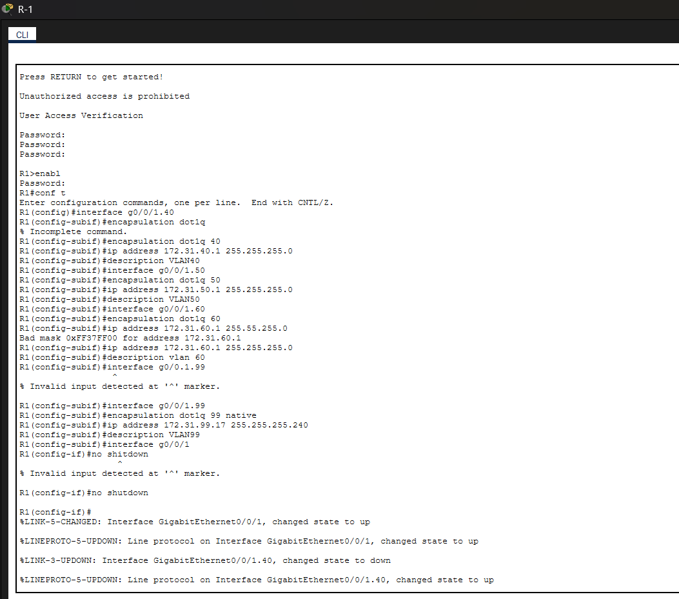
Figure 9. R1: subinterfaces g0/0/1.40, .50, .60 and .99 for router-on-a-stick.
Router-on-a-stick uses one physical interface, g0/0/1, split into one subinterface per VLAN. Each subinterface needs encapsulation dot1q <vlan-id>, an IP address in that VLAN's subnet, and (for this lab) a description. The parent interface has to be up as well, which is why no shutdown on g0/0/1 comes at the end and why the subinterface state changes to up right afterward.
Mistakes in Figure 9, all corrected in the screenshot:
- encapsulation dot1q with no VLAN ID: incomplete command.
- 255.55.255.0 on the VLAN 60 address: "Bad mask". Should be 255.255.255.0.
- interface g0/0.1.99: wrong numbering. Should be g0/0/1.99.
- no shutdown typed on a subinterface was rejected. It belongs on the physical interface.
The VLAN 99 subinterface uses encapsulation dot1q 99 native and a /28 mask (255.255.255.240), matching the management VLAN. Its address, 172.31.99.17, is what S-3 uses as its default gateway.

6. L3-SW1 (MSW-1): EtherChannels, routed port and SVIs

VLANs and the two EtherChannels
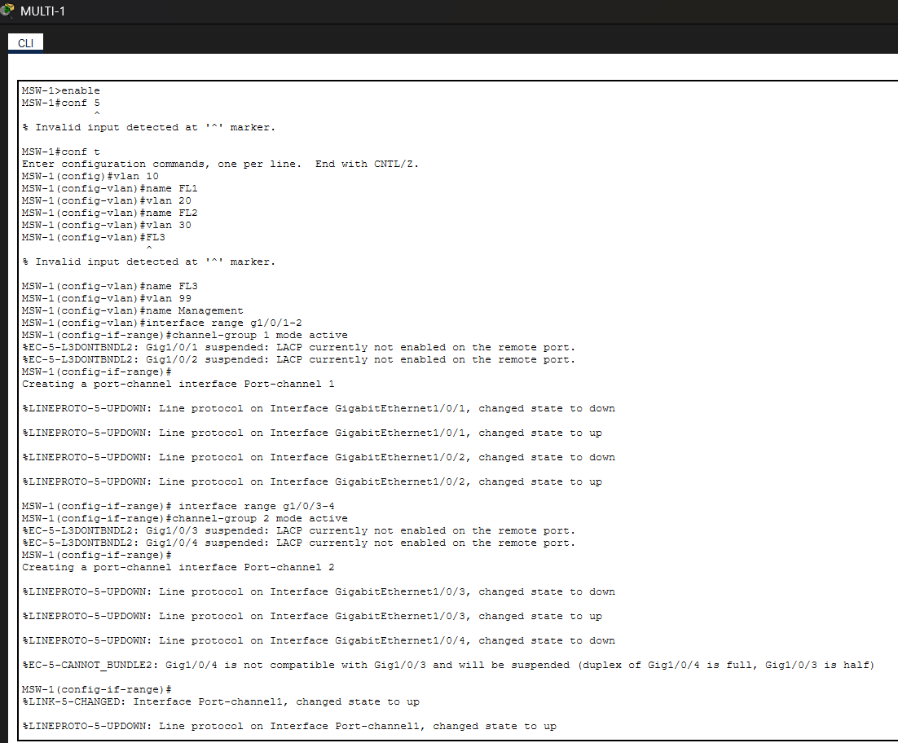
Figure 10. MSW-1: VLANs and creation of Port-channel 1 and 2.
VLANs 10, 20, 30 and 99 are created. conf 5 and a FL3 typed without name were typos and were retyped. g1/0/1-2 become Port-channel 1 (toward S-1) and g1/0/3-4 become Port-channel 2 (toward S-2), both with LACP active.
The duplex error shows up again here: Gig1/0/4 is full duplex and Gig1/0/3 is half, so one member is suspended. This is the same problem as on S-2 and gets the same fix (speed 1000, duplex full on the members).

Trunks
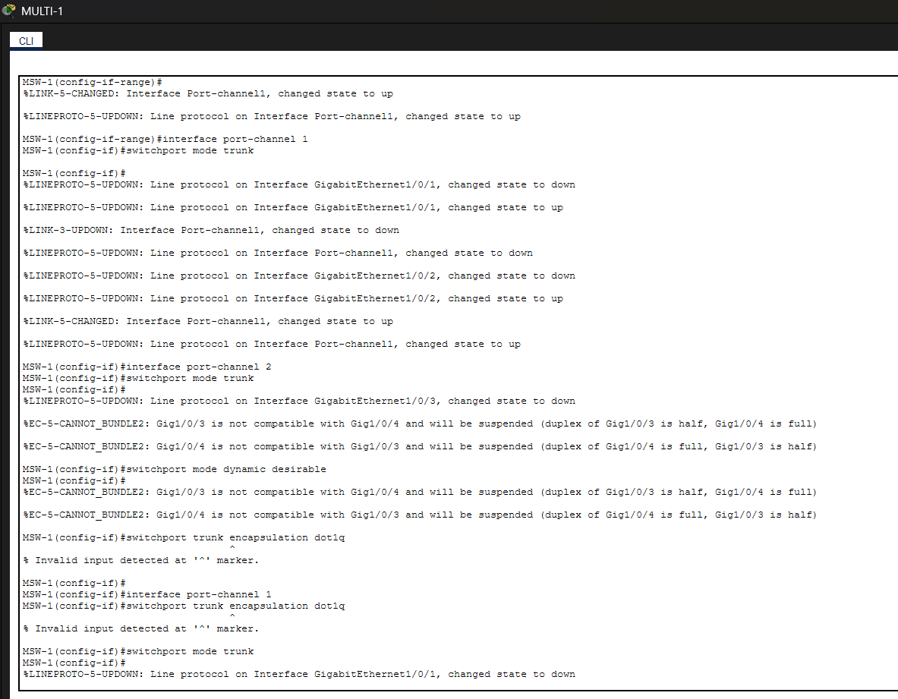
Figure 11. MSW-1: trunk mode on the port-channels and the rejected commands.
- switchport mode trunk on Port-channel 1 and 2 is correct.
- switchport mode dynamic desirable was then typed on Port-channel 2. That replaces the static trunk with a negotiated one, so it should be changed back to trunk.
- switchport trunk encapsulation dot1q was rejected with "Invalid input". This switch model only supports 802.1Q, so the command does not exist and is not needed. Older Catalyst 3560/3750 switches need it.

Routed port, SVIs and routing
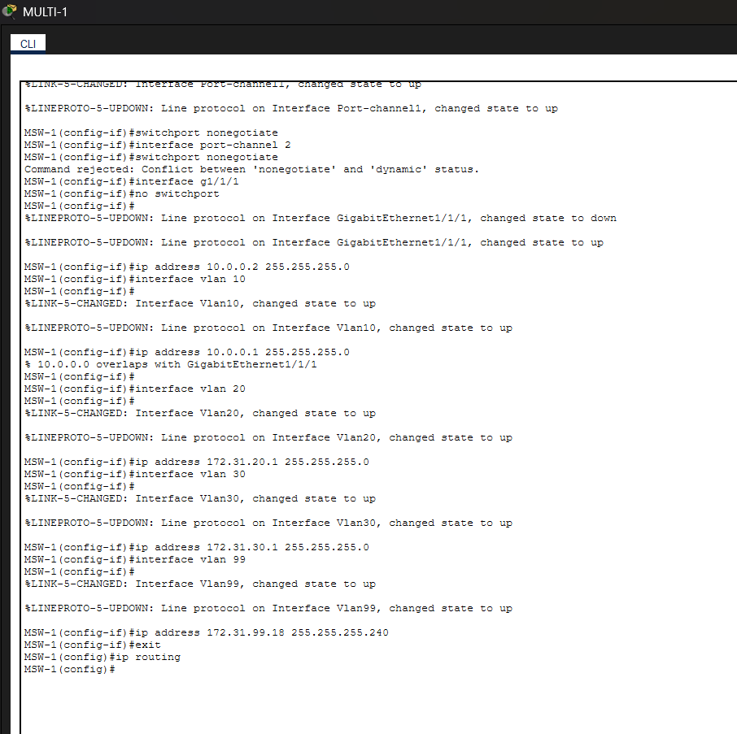
Figure 12. MSW-1: nonegotiate conflict, routed port g1/1/1, SVIs and ip routing.
- switchport nonegotiate worked on Port-channel 1 but was rejected on Port-channel 2 ("Conflict between nonegotiate and dynamic status") because Port-channel 2 was left in dynamic desirable. Setting it back to switchport mode trunk first fixes that.
- interface g1/1/1 with no switchport turns the port into a routed port so it can hold an IP address (10.0.0.2/24), the link to R1.
- SVIs for VLANs 20, 30 and 99 are created with addresses. ip routing at the end turns the switch into a router; without it the SVIs exist but nothing is forwarded between them.
- For VLAN 10, ip address 10.0.0.1 255.255.255.0 was typed by mistake and IOS answered "10.0.0.0 overlaps with GigabitEthernet1/1/1". That is IOS refusing two interfaces in the same subnet. The command did nothing, and the VLAN 10 SVI still has no IP address. It should be 172.31.10.1/24.

7. Error reference
Every error that appears in the screenshots, with the cause and the fix.
Device | Message | Cause | Fix
S-1, S-2, MSW-1 | %EC-5-L3DONTBNDL2 ... LACP not enabled on remote port | Other end not configured yet | Configure the far end with channel-group mode active or passive
S-2, MSW-1 | %EC-5-CANNOT_BUNDLE2 ... duplex half / full | Members have different duplex | speed 1000 and duplex full on both members, both ends
S-2 | %SPANTREE-2-RECV_PVID_ERR / BLOCK_PVID_LOCAL | Trunk on one end, access on the other | switchport mode trunk on Port-channel 3 on both switches
S-2 | dtp mode of Gig0/2 is off, Po2 is on | Suspended member kept old settings | Fix the duplex, let the member rejoin
S-2 | interface fa0/16-24 invalid | Missing range | interface range fa0/16-24
S-2 | interface rangeg0/1-2 invalid | Missing space | interface range g0/1-2
S-3 | Management invalid | Missing name | name Management
S-3 | Can not have both a user password and a user secret | Two credential types on one user | no username admin password ..., then use secret
R1 | interface go/o/o invalid | Letters instead of digits | interface g0/0/0
R1 | % Incomplete command (ip address, encapsulation dot1q) | Missing argument | Add address / VLAN ID
R1 | Bad mask 0xFF37FF00 | 255.55.255.0 typo | 255.255.255.0
R1 | interface g0/0.1.99 invalid | Wrong numbering | interface g0/0/1.99
R1 | no shutdown invalid on subinterface | Wrong level | Run it on g0/0/1
R1 | Default route without gateway ... may impact performance | Static route uses exit interface on Ethernet | Use next-hop IP (optional)
MSW-1 | conf 5, FL3 invalid | Typos | conf t, name FL3
MSW-1 | switchport trunk encapsulation dot1q invalid | Platform is dot1q only | Not needed
MSW-1 | Conflict between nonegotiate and dynamic status | Port-channel 2 in dynamic desirable | Set switchport mode trunk, then nonegotiate
MSW-1 | 10.0.0.0 overlaps with GigabitEthernet1/1/1 | Wrong address on VLAN 10 SVI | ip address 172.31.10.1 255.255.255.0

8. Things to check before finishing
These come from reading the screenshots. Some depend on the Addressing Table in the instruction sheet, which is not visible here, so treat them as items to verify.
- S-3 management address. The SVI has 10.0.99.18/28 but the default gateway is 172.31.99.17. They are in different subnets, so the gateway is unreachable. The address is most likely meant to be in 172.31.99.16/28 (usable .17 to .30, with .17 already used by the router).
- Duplicate VLAN 99 address. MSW-1 has its VLAN 99 SVI at 172.31.99.18/28. If S-3 is corrected to .18 as well, two devices share an address, and MSW-1 would also have a connected route into the Arts management subnet. Check the Addressing Table for what each device should use, and whether L3-SW1 needs an SVI in VLAN 99 at all.
- VLAN 10 SVI on MSW-1 has no IP address (section 6). Add 172.31.10.1/24.
- Port-channel 2 on MSW-1 is in dynamic desirable. Set it to static trunk.
- Half-duplex members on S-2 (Gig0/2) and MSW-1 (Gig1/0/3). Fix and check with show etherchannel summary.
- S-3 account password case. In the screenshot the first attempt used C1sco123! and the corrected username admin ... secret line uses c1sco123! with a lowercase c, while the enable secret uses a capital C. Passwords are case sensitive, so use whichever the lab specifies and be consistent.
- Default routes. No default route is visible on MSW-1 (it needs ip route 0.0.0.0 0.0.0.0 10.0.0.1 to send traffic to R1) or on R1 toward the ISP. Both are needed for pings to the Outside Server at 203.0.113.100. If they were configured in an earlier part of the lab, ignore this.
- Descriptions on every interface. Step 2b of Part 5 asks for this. The R1 subinterfaces and s0/1/0 have them; g0/0/0 and the switch interfaces are not shown with one.
- Host default gateways (Part 5 Step 3): 172.31.10.1, .20.1, .30.1 for the Sciences hosts, .40.1, .50.1, .60.1 for the Arts hosts, 172.31.99.17 for the management PC.
- Save each device with copy running-config startup-config.

9. Verification commands
Command | What to look for
show vlan brief | VLANs exist, ports are in the right VLAN
show etherchannel summary | Port-channels marked SU, members marked P
show interfaces trunk | Port-channels and g0/1 (S-3) trunking, native VLAN 99 where expected
show interfaces status | Speed and duplex of each member port
show spanning-tree | Which ports are forwarding or blocking (the orange link in Figure 1)
show ip interface brief | Interfaces up/up with the right addresses
show ip route | Connected and static routes on R1 and MSW-1
ping between hosts | Same-VLAN, cross-VLAN, and to 203.0.113.100
ssh -l admin 172.31.99.x from a host | Login to S-3 works (Part 5 Step 3c)

Appendix: clean configurations
These are the commands from the screenshots with the typing mistakes removed and the fixes from section 8 applied where the right value is clear. Anything that depends on the Addressing Table is marked with angle brackets.

S-1 (Sw-A)
vlan 10
name FL1
vlan 20
name FL2
vlan 30
name FL3
interface range fa0/7-10
switchport mode access
switchport access vlan 10
interface range fa0/11-15
switchport mode access
switchport access vlan 20
interface range fa0/16-24
switchport mode access
switchport access vlan 30
interface range g0/1-2
channel-group 1 mode active
interface range fa0/5-6
channel-group 3 mode active
interface port-channel 1
switchport mode trunk
interface port-channel 3
switchport mode trunk

S-2 (Sw-B)
vlan 10
name FL1
vlan 20
name FL2
vlan 30
name FL3
interface range fa0/7-10
switchport mode access
switchport access vlan 10
interface range fa0/11-15
switchport mode access
switchport access vlan 20
interface range fa0/16-24
switchport mode access
switchport access vlan 30
interface range g0/1-2
speed 1000
duplex full
channel-group 2 mode active
interface range fa0/5-6
channel-group 3 mode active
interface port-channel 2
switchport mode trunk
interface port-channel 3
switchport mode trunk

S-3 (Sw-C)
vlan 40
name BDG4
vlan 50
name BDG5
vlan 60
name BDG6
vlan 99
name Management
interface range fa0/1-5
switchport mode access
switchport access vlan 40
interface range fa0/6-10
switchport mode access
switchport access vlan 50
interface range fa0/11-15
switchport mode access
switchport access vlan 60
interface fa0/24
switchport mode access
switchport access vlan 99
interface vlan 99
ip address <address in 172.31.99.16/28> 255.255.255.240
ip default-gateway 172.31.99.17
ip domain-name acad.pt
username admin privilege 15 secret <password>
enable secret <password>
crypto key generate rsa ! 1024 bits
ip ssh version 2
line vty 0 15
transport input ssh
login local
interface g0/1
switchport mode trunk
switchport trunk native vlan 99
switchport nonegotiate

R1 (Edge-Router)
hostname R1
enable secret class
service password-encryption
banner motd "Unauthorized access is prohibited"
line console 0
password cisco
login
line vty 0 15
password cisco
login
ip route 172.31.10.0 255.255.255.0 10.0.0.2
ip route 172.31.20.0 255.255.255.0 10.0.0.2
ip route 172.31.30.0 255.255.255.0 10.0.0.2
interface g0/0/0
ip address 10.0.0.1 255.255.255.0
description Link to L3-SW1
no shutdown
interface s0/1/0
ip address 209.165.201.2 255.255.255.252
description Connected to ISP
no shutdown
interface g0/0/1
no shutdown
interface g0/0/1.40
encapsulation dot1q 40
ip address 172.31.40.1 255.255.255.0
description VLAN40
interface g0/0/1.50
encapsulation dot1q 50
ip address 172.31.50.1 255.255.255.0
description VLAN50
interface g0/0/1.60
encapsulation dot1q 60
ip address 172.31.60.1 255.255.255.0
description VLAN60
interface g0/0/1.99
encapsulation dot1q 99 native
ip address 172.31.99.17 255.255.255.240
description VLAN99
The static routes above use the next hop 10.0.0.2 instead of the exit interface used in the screenshot (see section 5). The description on g0/0/0 is added because Part 5 asks for descriptions on all interfaces.

L3-SW1 (MSW-1)
vlan 10
name FL1
vlan 20
name FL2
vlan 30
name FL3
vlan 99
name Management
interface range g1/0/1-2
channel-group 1 mode active
interface range g1/0/3-4
speed 1000
duplex full
channel-group 2 mode active
interface port-channel 1
switchport mode trunk
switchport nonegotiate
interface port-channel 2
switchport mode trunk
switchport nonegotiate
interface g1/1/1
no switchport
ip address 10.0.0.2 255.255.255.0
interface vlan 10
ip address 172.31.10.1 255.255.255.0
interface vlan 20
ip address 172.31.20.1 255.255.255.0
interface vlan 30
ip address 172.31.30.1 255.255.255.0
interface vlan 99
ip address <per Addressing Table> 255.255.255.240
ip routing
ip route 0.0.0.0 0.0.0.0 10.0.0.1

